JSP 822 – Training Implementation Plan

 | Name | Function
Document Author | DSAT Consultancy | TNA Plan
Authorised by | JSP 822 Course
Quality Assurance Approval | TNA Training | Course Design

Revision No | Revision Authorised by  Name | Revision Date

Table of Contents
Table of Contents 2
Acronyms/Abbreviations/Definitions 3
References 3
JSP 822 Training Implementation PlanS 4
1.1.1 Sub Tasks 4
1.1.2 Task Milestones 5
1.1.3 Task Timings 5
1.2 baselines 6
1.2.1 Setting A Baseline Within A Project Plan 6
1.3 Lag And Lead Times 8
1.3.1 Inserting A Lag Or Lead 8
1.4 SubProjects 9
1.4.1 Insert A Subproject Plan Into A Larger Project Plan 9
1.4.2 Remove/Delete A Subproject From A Larger Project Plan 10
2. Building a Project Team 11
2.1 Locating Build Team Dialogue 11
2.2 Resource Types 11
2.3 Booking Type 12
2.4 Building a Project Team 12
2.5 Graphs 12
2.6 Match and Replace 14
2.6.1 Matching Resources 14
2.6.2 Replacing Resources 14
2.7 Assigning Resources 14
2.7.1 Assign Resources Dialogue 15
2.7.2 Resource Names Column 15
2.7.3 Resource Tab within Task Information 15
2.7.4 Task Form 15

Acronyms/Abbreviations/Definitions
MS PROJECT | Enterprise Project Management
PWA | Project Web Access
RAG | Red, Amber, Green
RBS | Resource Breakdown Structure

References

 | Reference No: | Document Title
1
2
3
4
5

JSP 822 Training Implementation PlanS
Once a task has subtasks assigned the task becomes a summary and the subtasks can be “rolled up” or “rolled out” using the minus icon to the left of the task name, for JSP 822 TNA project plans contact DSAT Consultancy.

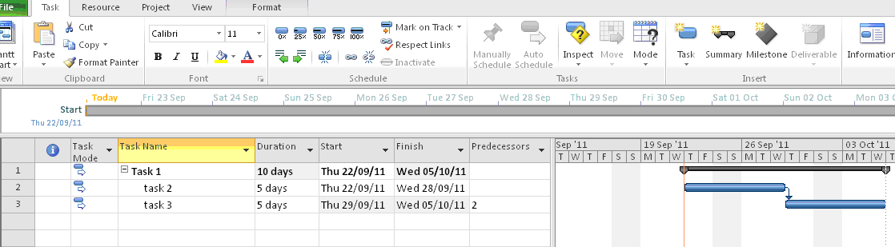

Sub Tasks

Tasks can be broken down into a series of smaller subtasks. This makes tasks easier to manage and makes it easier to see who is responsible for each aspect of a task.

Subtasks are created by filling in the task name and duration as normal and while the task name is highlighted, clicking on the right side facing, green arrow (indent arrow) on the task tab ribbon.

When you indent a task it becomes a subtask of the preceding higher level task. Subtasks can be hidden from view if a summary of the plan is required by clicking on the minus sign to the left of the task title.

Task Milestones

Milestones are used to represent delivery dates and important events within the plan for example, tank build completed.
Milestones are entered as a task, have a diamond shaped symbol and always have a duration of “0” days. They can also be inserted using the milestone button of the task tab ribbon.

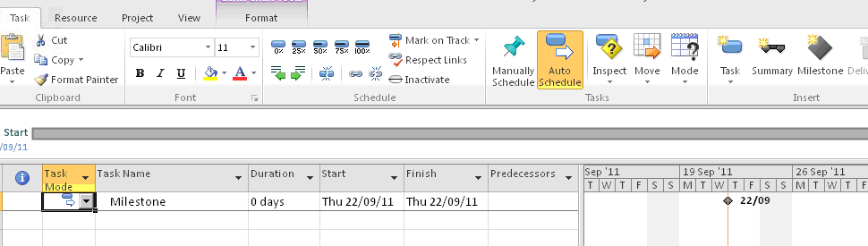

Task Timings

Timings for a task are entered in the duration column or by using the up/down arrows within the column. Duration is quantified using “m” for minutes, “h” for hours, “d” for days, ”w” for weeks and “m” for months and is placed after the numerical quantity.

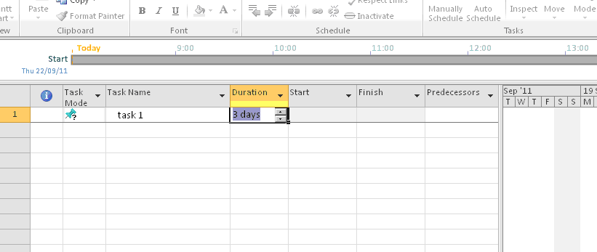

Start and finish dates are applied in the Start and Finish columns. Clicking on the drop down arrow brings up a calendar to select the relevant date from.

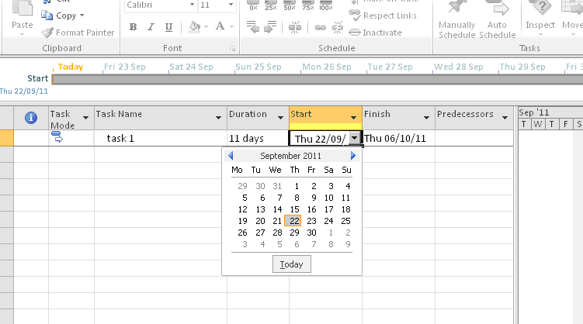
JSP 822 Course 1

baselines

Baselines are applied to a project plan to provide an indication of how the original plan is intended to run. It gives the user an indication of how much the current plan has been modified compared to when the baseline was applied. A JSP 822 training project plan should only have a baseline applied when planning and estimation are complete.

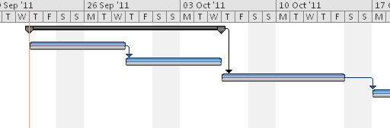

Setting A Baseline Within A Project Plan

To set a baseline, first click on the Set Baselines icon in the project tab and then click on Set Baseline.

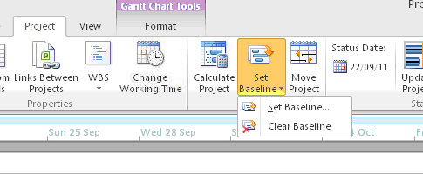
TNA Course 1

From the subsequent set baseline dialogue box, using the dropdown menu, select the required baseline. Initially select “baseline” and subsequently use the numbered baselines. Make sure the Entire Project radio button is selected.

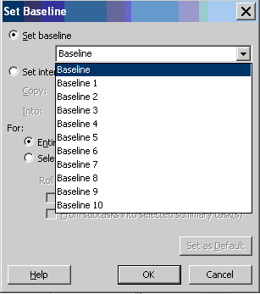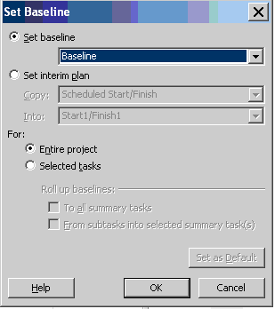

To show the baseline as a bar on the Gantt chart view, on the format tab, click on the baseline button and select the relevant baseline from the drop down menu.

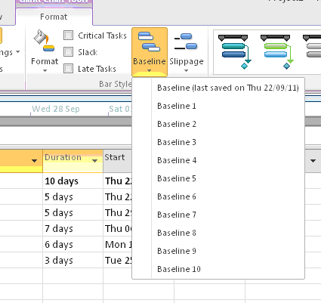

Lag And Lead Times

A lag occurs when there is a built in time delay between one task finishing and another task starting which cannot be managed by the user. A lead occurs when two tasks that affect each other can be run concurrently.

Inserting A Lag Or Lead TO A JSP 822 Plan

To insert a lag between two tasks, place the cursor in the predecessor column of the task to be linked to and type in the row number of the task above it. Follow the row number with “FS+” followed by the number of days the lag is to cover. This connects the finish of the first task to the start of the second task.

To insert a lead between two tasks, place the cursor in the predecessor column of the task to be linked to and type in the row number of the task above it. Follow the row number with “FS-” followed by the number of days the lead is to cover. This connects the finish of the first task to the start of the second task.

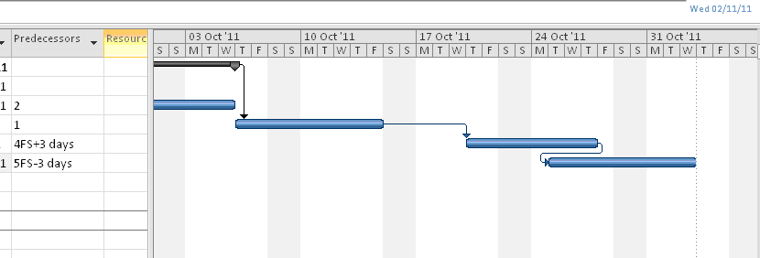
Lag
Lead

Substituting “FS” in the predecessor column with “SS”, “FF” or “SF” will display the following results:

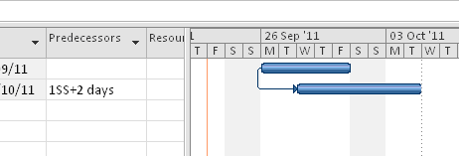

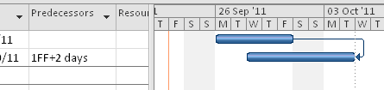

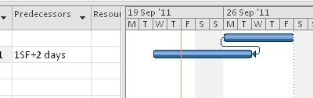

JSP 822 SubProjects
A subproject is a smaller project embedded within a larger, over-arching project upon which it has an impact. Subprojects are used for embedding work packages and requests for change (RfC’s) within the larger project plan.

Insert A Subproject Plan Into A Larger Project Plan

To insert a subproject into a larger project plan, select the row below where you want to insert the subproject, and on the project tab select the subproject button.

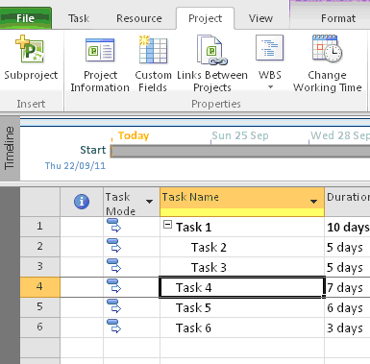

In the subsequent dialogue box, select the required plan for insertion and select read/write or read only access for the subproject. Click insert to embed the subproject into the larger project plan.

Remove/Delete A Subproject From A Larger Project Plan

To remove/delete a subproject from a larger project plan, with the mouse, right click on the row number and select delete task.

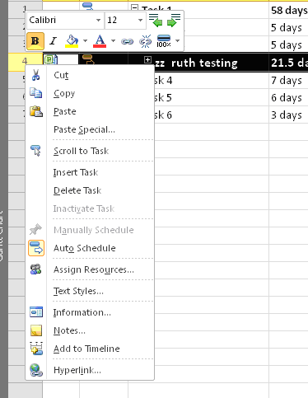

Make sure that the continue radio button is selected and click on OK. The selected subproject, its tasks and subtasks will be removed/deleted from the larger project plan.

Building a JSP 822 Project Team

Building a Team within Microsoft Project Professional 2010 allows users to build a JSP 822 Course proposed, or an agreed, Team of Resources to work on a project. Resources can be either generic (skill based), or non-generic (named).

Additional options available within the Build Team dialogue allow users to check a Resources availability, filter lists of Resources by selected criteria and Match Resources against specific skills sets.

Locating Build training Team Dialogue
- Open Microsoft Project Professional

- Select the Resource tab ►Add Resource

The dialogue box has several different elements:

Filtering | The Build Team dialogue will display all resources available to the user from the Project Server database. In some cases the resource pool may be quite big. To make finding the correct Resource easier the list can be filtered using the following options:  - Existing Filters – are the default filters provided by the application  - Customised Filters – can be created utilising Custom Resource Fields that are unique to the enterprise  - Resource Availability – can be used to filter Resource lists by their individual availability within the system
Grouping | Like filtering, the Grouping option allows users to group together the list of Resources on the left by either default fields or by Custom Resource Fields.

Training Resource Types

When reviewing the list of Resources in the Build Team dialog it can be noted that some Resources are displayed with an additional symbol shown within the indicator column. These symbols are also shown within the indicator column of Resource Views.

Signifies a Local Resource. Local Resources are unique (local) to the plan in which they appear and therefore cannot be shared or reported upon within the Enterprise.

Signifies a Generic Resource. Generic Resources are often used for proposed scheduling, they do not have tasks communicated to them or have timesheets created. Generic Resources are often named by their Skill or Role within the Enterprise –it is recommended that these are used initially; replacing them with named resources once agreed reducing the need for the Booking Type field and allowing future requirement reporting.

No Symbol | Signifies a non-generic Enterprise Resource. These are held in the Enterprise Resource Pool and are stored in the Project Server database making them centrally available. As these are stored centrally users are able to view availability and report on activities across other plans.

Booking Type

Project Professional provides a field called Booking Type that allows Resources to be assigned to a project as either ‘proposed’ or ‘committed’. On assigning Resources to a project as ‘proposed’, their availability is not reduced and task/timesheet entries are not generated. On publishing a plan after changing the Booking Type field to ‘committed’ task/timesheet entries etc. will be generated.

Building a Project Team
- Select the Resource tab

- Click on Add Resources ►Build Team from Enterprise…

- Select the resources required

- Select Add to build the team

Resource selected should now appear in the team on the right hand side.
- Set the resource booking type

- Click OK to complete the operation

Graphs
The graph function allows the user to see Work, Remaining Work and Remaining Availability for single resources.
To display a graph, in the Build Team Dialogue box, select the resources required and click on the Graphs button between the two resource lists.

PLACE HOLDER Assignment Work by Resource graph

Resources are included in projects as either proposed or committed. By default only work for committed resources is included in Remaining Availability. Changing this option will also include work for proposed resources.

This will open the Resource Availability View in Project Web Access (PWA) in a separate window.

The user can then see the availability, and include that resource in their team accordingly. The window can be closed once it has served its purpose.

Match and Replace
As it is advised to initially plan with Generic Resources and then swap them for “real” or “named” Resources, Microsoft Project Professional gives users the ability to Match Generic Resources to Named Enterprise Resources within the Build Team dialogue.

This functionality relies on a Resource Custom Field being defined against each Resource in the Enterprise Resource Pool, such as Skill. Administrators will also need to enable the “Use this field for matching generic resources” option against this field.

Once a matching Resource has been located and is required to replace the Generic assignment Project Professional allows users to replace (swap) that assignment in a single click. Then any task that the generic resource was on will be replaced with the named resource without having to go into the plan and manually change them.

Matching Resources
- In the Build Team from Enterprise dialogue highlight a Generic (or specific) Resource within the right column

- Click the Match button

This will filter the list of Resources displayed in the left column

Replacing Resources
- Highlight a Resource on the left and click the Replace button

The Generic Resource within the right column will then be Replaced with the named Resource from the left.

◎ | The Replace function will only allow one named Resource to be replaced for a Generic Resource. In effect it replaces every occurrence of the generic resource with the first named resource. If the user is replacing a generic resource with two named resources the named resources will have to be added to the team and then the generic resource will have to be replaced manually.

Assigning Resources
Having Built a Team within a project plan, users now need to assign Resources to specific tasks.

Microsoft Project Professional 2010 provides users with several methods to create Resource Assignments.

  | Assigning Resources to tasks should only be done after a Team has been built. This avoids the use of Local Resources which should not be used in an Enterprise environment.

Assign Resources Dialogue
- Click the Assign Resources button found on the Resource tab (Alt+F10)

This will open the Assign Resources dialogue above the project plan. It will not disappear even if it becomes inactive, this is so both the plan and dialogue box can be used together.
- Select a Task on the plan to Assign Resources to

- Select one or more Resources from the Assign Resources dialogue to Assign to the Task

- Click the Assign button

Resource Names Column

The Resource Names column appears within the default Gantt Chart view within Microsoft Project. Once a Team has been built selecting a cell under Resources Names will reveal a drop-down of the available Resources from the Team. This will appear as a tick list to allow the selection of multiple resources.

Resource Tab within Task Information
- Right click the Task that requires Resource Assignments

- Select Task Information from the drop list

This will open the Task Information dialogue. This can also be opened by double clicking the Task.
- Select the Resources tab

- Select the first cell under the Resource Name column to reveal a drop-down of available Resources

- Select the required Resource

- For additional Assignments repeat steps 4 – 5 on the next empty cell

Task Form
- Select the View tab and check the box Details

This will split the screen to show the Task Form view in the bottom half of the screen
- Select a task on the plan to assign the resource to

- Within the Task Form select the first cell under the Resource Name column to reveal a drop down of available resources

- Select the resources required

- For additional assignments repeat steps 3-4 on the next empty cell

- Select OK

